Restaurant Billing System

Computer Science Project

Developed By:

Chaitanya Sharma

Mothers International School

www.themis.in

#01/19

Index

|  |  |  |
| --- | --- | --- |
| S.no. | Description | Page no. |
| 1. | Certificate | 03 |
| 2. | Acknowledgement & References | 04 |
| 3. | Introduction | 05 |
| 4. | Source Code | 06 |
| 5. | Output screen | 15 |
| 6. | Hardware & Software requirement | 19 |

Page: #02/19

**Certificate**

This is to certify that **Restaurant Billing System** Computer Science Project is Developed by **Chaitanya Sharma** under my supervision in the computer lab ofMothers International School, Hauz khas in the session 2018-2019. The work done by them is original.

Mr. Ashwin Dash

Computer Science Teacher

Date:______________

Page: #03/19

**Acknowledgement**

I would like to express my sincere gratitude to my computer teacher Mr. Ashwin Dash for her vital support, guidance and encouragement without which this project would not come forth from my side. Who helped me completing the project by giving ideas, thoughts and made this project easy and accurate.

I wish to thank my parents for their undivided support and interest who inspired me and encouraged me to go my own way, without which i would be unable to complete my project.

**Reference**

1. [www.google.com/c++project](http://www.google.com/c++project)
2. [www.wikipedia.com/c++project](http://www.wikipedia.com/c++project)
3. Class notes

Page: #04/19

Introduction

A restaurant billing system mainly focuses on billing system of a restaurant.

It is designed to ease the process of generating a bill in a restaurant.

This system uses extensively the file systems of C++. It will be having separate functions for:

* Displaying the menu.
* Registering the customer details and allotting them their table numbers and customer number accordingly.
* Searching the customer by their name or by their customer number (as entered by the user) and displaying their details.
* Calculating the total amount and then generating the bill.

In the software developed separate functions will be there for each of the following points so that there is ample scope for adding more features in the near future.

Page: #05/19

Source Code

#include<conio.h>

#include<string.h>

#include<fstream.h>

#include<iomanip.h>

#include<stdio.h>

class CUSTOMER //capitalization for better readability

{

int CusTabno,Tabno;

char CName[10];

public:

int flag;//flag=1 if customer is in restaurant, flag=0 when customer leaves restaurant

int RCusTabno()

{ return CusTabno; }

char* RCName()

{ return CName; }

void Input();

void Output();

};

void CUSTOMER::Input()

{

cout<<"Name: ";gets(CName);

fstream file;

CUSTOMER C;

int CN=0;

file.open("C.dat",ios::binary|ios::in);

while(file.read((char*)&C,sizeof(C)))

{

CN++;

}

cout<<"Customer Number: "<<++CN<<endl;

CusTabno=CN;

cout<<"Table Number: "<<CN<<endl;

Tabno=CN;

flag=1;

cout<<"Welcome To The Restaurant";

}

void CUSTOMER::Output()

{

cout<<"NAME: "<<CName<<endl;

cout<<"Customer No.: "<<CusTabno<<endl;

cout<<"Table No.: "<<Tabno<<endl;

}

const int Max=5;

const char VL=179,HL=196,TL=218,TR=191,BL=192,BR=217;

const char DVL=186,DHL=205,DTL=201,DTR=187,DBL=200,DBR=188;

void Color(int TC,int BC)//For Changing Text Color and Text Background

{

textcolor(TC);

textbackground(BC);

}

void ShowXY(int X,int Y,char CH)//Displays a character at X,Y position

{

gotoxy(X,Y);

cprintf("%c",CH); //cout<<CH;

}

void ShowXY(int X,int Y,char CH[])//Displays a string at X,Y position

{

gotoxy(X,Y);

cprintf("%s",CH); //cout<<CH;

}

void Vline(int X,int Y,int L)//To vertical line by joining vert. characters

{

for (int i=Y;i<=Y+L;i++)

ShowXY(X,i,VL);

}

void Hline(int X,int Y,int L)//To horizontal line by joining hor.characters

{

for (int i=X;i<=X+L;i++)

ShowXY(i,Y,HL);

}

void Recta(int C1,int R1,int C2,int R2)

{

ShowXY(C1,R1,TL); //

ShowXY(C1,R2,BL); //Placing corner characters

ShowXY(C2,R1,TR); //

ShowXY(C2,R2,BR); //

Vline(C1,R1+1,R2-R1-2); //

Vline(C2,R1+1,R2-R1-2); //Joining Corners by Vertical lines

Hline(C1+1,R1,C2-C1-2); //

Hline(C1+1,R2,C2-C1-2); //Joining Corners by Horizontal lines

}

void DVline(int X,int Y,int L)

{

for (int i=Y;i<=Y+L;i++)

ShowXY(X,i,DVL);

}

void DHline(int X,int Y,int L)

{

for (int i=X;i<=X+L;i++)

ShowXY(i,Y,DHL);

}

void DRecta(int C1,int R1,int C2,int R2)

{

ShowXY(C1,R1,DTL);

ShowXY(C1,R2,DBL);

ShowXY(C2,R1,DTR);

ShowXY(C2,R2,DBR);

DVline(C1,R1+1,R2-R1-2);

DVline(C2,R1+1,R2-R1-2);

DHline(C1+1,R1,C2-C1-2);

DHline(C1+1,R2,C2-C1-2);

}

//X,Y are coordinates for displaying menu

//Mnu all choices which required to be displayed as Menu Choices

//Noc no. of choices

int Vmenu(int X,int Y,char Mnu[][20],int Noc)

{

Color(WHITE,BLUE);

Recta(X,Y,X+strlen(Mnu[0])+1,Y+Noc+1);

for (int i=0;i<Noc;i++)

ShowXY(X+1,Y+i+1,Mnu[i]);

int Sel=0,Exit=0;//Sel - Current Selected Option

//Exit- Control Variable for loop

do

{

int Tsel=Sel; //To store the current selection in Tsel

Color(BLUE,WHITE);

ShowXY(X+1,Y+Sel+1,Mnu[Sel]);

Color(WHITE,BLUE);

char Cho=getch();

//71:Home 72:Up 73:Pup 75:Left 77:Right 79:End 80:Dn 81:PD

switch(Cho)

{

case 71:Sel=0;break;

case 79:Sel=Noc-1;break;

case 72:if (Sel==0)

Sel=Noc-1;

else

Sel--;

break;

case 80:if (Sel==Noc-1)

Sel=0;

else

Sel++;

break;

case 13:Exit=1; //Enter Key

break;

case 27:Sel=-1; //Escape

Exit=1;

break;

}

ShowXY(X+1,Y+Tsel+1,Mnu[Tsel]);

}

while (!Exit);

return Sel;

}

int Hmenu(int X,int Y,char Mnu[][20],int Noc)

{

Color(WHITE,BLUE);

for (int i=0;i<Noc;i++)

ShowXY(X+15*i+1,Y,Mnu[i]);

int Sel=0,Exit=0;

do

{

int Tsel=Sel; //To store the current selection in Tsel

Color(BLUE,WHITE);

ShowXY(X+15*Sel+1,Y,Mnu[Sel]);

Color(WHITE,BLUE);

char Cho=getch();

//71:Home 72:Up 73:Pup 75:Left 77:Right 79:End 80:Dn 81:PD

switch(Cho)

{

case 71:Sel=0;break;

case 79:Sel=Noc-1;break;

case 75:if (Sel==0)

Sel=Noc-1;

else

Sel--;

break;

case 77:if (Sel==Noc-1)

Sel=0;

else

Sel++;

break;

case 13:Exit=1;

break;

case 27:Sel=-1;

Exit=1;

break;

}

ShowXY(X+15*Tsel+1,Y,Mnu[Tsel]);

}

while (!Exit);

return Sel;

}

void ClearArea(int C1,int R1,int C2,int R2)

{

window(C1,R1,C2,R2);

clrscr();

window(1,1,80,25);

}

void Home();

void DisplayAll();

void Billing();

void Register();

void Search();

void SearchCName();

void SearchCNumber();

void BillGeneration();

void main()

{

clrscr();

CUSTOMER C[20];

char MainMenu[][20] = {

"HOME ",

"REGISTER ",

"SEARCH ",

"BILLING ",

"EXIT "

};

int Ch;

do

{

Color(WHITE,BLUE);

clrscr();

Ch = Hmenu(1,1,MainMenu,5);

switch(Ch)

{

case 0:Home(); break;

case 1:Register(); break;

case 2:Search(); break;

case 3:Billing();

}

}while(Ch!=4);

getch();

}

void DisplayAll()

{

fstream file;

CUSTOMER C;

file.open("C.dat",ios::binary|ios::in);

while(file.read((char*)&C,sizeof(C)))

{

C.Output();

}

file.close();

}

void SearchCName()

{

fstream file;

CUSTOMER C;

char Name[20];

int Found=0;

file.open("C.dat",ios::binary|ios::in);

gotoxy(0,10);

cout<<"Enter the Name of the Customer: ";

gets(Name);

while(file.read((char*)&C,sizeof(C)))

{

if(strcmpi(C.RCName(),Name)==0)

{

C.Output();

Found++;

}

}

if(Found==0)

cout<<"Customer record not found"<<endl;

file.close();

getch();

}

void SearchCNumber()

{

fstream file;

CUSTOMER C;

int Number;

int Found=0;

file.open("C.dat",ios::binary|ios::in);

gotoxy(0,10);

cout<<"Enter the Customer Number: ";

cin>>Number;

while(file.read((char*)&C,sizeof(C)))

{

if(C.RCusTabno()==Number)

{

C.Output();

Found++;

}

}

if(Found==0)

cout<<"Customer record not found"<<endl;

file.close();

getch();

}

void Billing()

{

fstream file;

CUSTOMER C;

int Number,Found=0;

file.open("C.dat",ios::binary|ios::in|ios::out);

gotoxy(10,10);

cout<<"Enter the Customer Number: ";

cin>>Number;

while(!Found&&file.read((char*)&C,sizeof(C)))

{

if(C.RCusTabno()==Number)

{

Found++;

C.flag=0;

}

}

if(Found)

{

int N= file.tellg()-sizeof(C);

file.seekp(N);

file.write((char*)&C,sizeof(C));

BillGeneration();

}

else

cout<<"No Record found for entered Customer no."<<endl;

file.close();

}

void Home()

{

ShowXY(5,5,"WELCOME TO METRO RESTAURANT");

ShowXY(5,10,"Total Tables: 20");

ShowXY(5,11,"Tables Occupied: ");

fstream file;

file.open("C.dat",ios::binary|ios::in);

CUSTOMER C;

int CN=0;

while(file.read((char*)&C,sizeof(C)))

{

if(C.flag==1)

CN++;

}

cout<<CN;

ShowXY(5,12,"Tables Available: ");

cout<<(20-CN);

cout<<"\nRESTAURANT MENU"<<endl;

cout<<"(1) Cheese Pizza(Rs. 50) \n(2) Aloo Tikki Burger(Rs. 30) \n(3) Dimsums(Rs. 30) \n(4) Chocolate Pastry(Rs. 50) \n(5) Butterscotch Milkshake(Rs. 40)";

cout<<"\nVIEW ALL CUSTOMER RECORDS?(Y/N)";

char ch;

cin>>ch;

if (ch=='y'||ch=='Y')

DisplayAll();

getch();

}

void Register()

{

fstream file;

CUSTOMER C;

gotoxy(10,10);

file.open("C.dat",ios::binary|ios::app);

C.Input();

file.write((char*)&C,sizeof(C));

file.close();

getch();

}

void Search()

{

char SMenu[][20] = {

"By Customer's Name" ,

"By Customer No." ,

};

int Ch;

Ch = Vmenu(32,3,SMenu,2);

switch(Ch)

{

case 0: gotoxy(5,10);

SearchCName(); break;

case 1: gotoxy(5,10);

SearchCNumber();

}

getch();

}

void BillGeneration()

{ gotoxy(0,10);

int Amount=0,N,ORDER[10];

cout<<"Number of Dishes Ordered: ";cin>>N;

for(int i=0; i<N; i++)

{

cout<<"Enter dish "<<i+1<<":"<<endl;

cin>>ORDER[i];

}

for(int j=i; j<10; j++)

{

ORDER[j]=0;

}

for(i=0; i<10; i++)

{

if (ORDER[i]==1||ORDER[i]==4)

Amount+=50;

else if (ORDER[i]==2||ORDER[i]==3)

Amount+=30;

else if (ORDER[i]==5)

Amount+=40;

else

Amount+=0;

}

cout<<"Bill Amount: "<<Amount<<endl;

cout<<"Amount+Taxes: "<<((5*Amount)/100)+Amount;

getch();

}

Page: #14/19

Output Screens

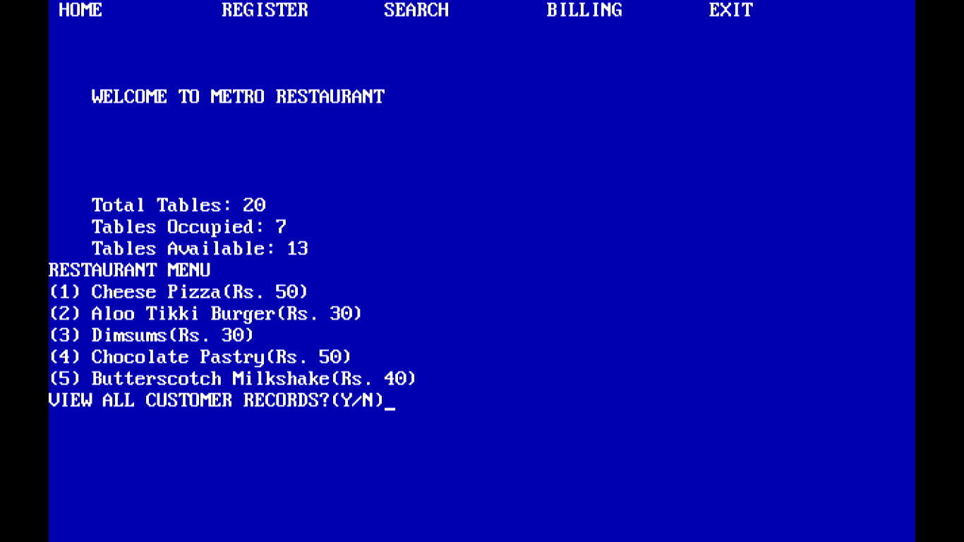

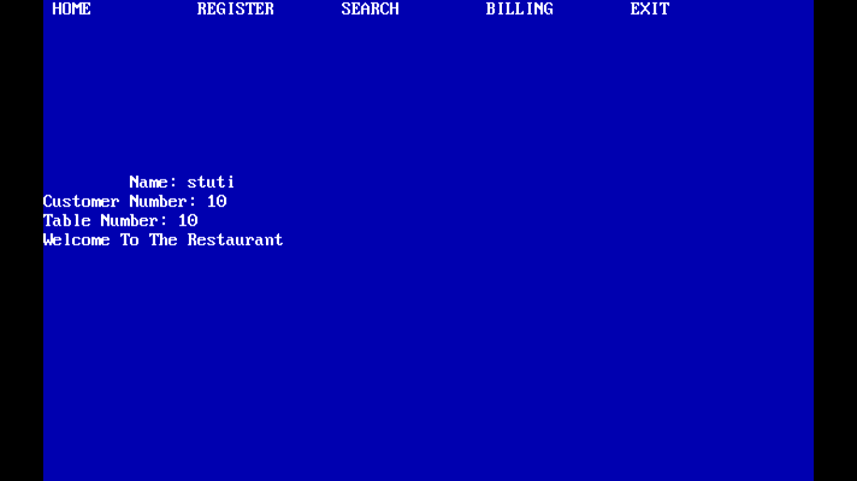

Page: #15/19

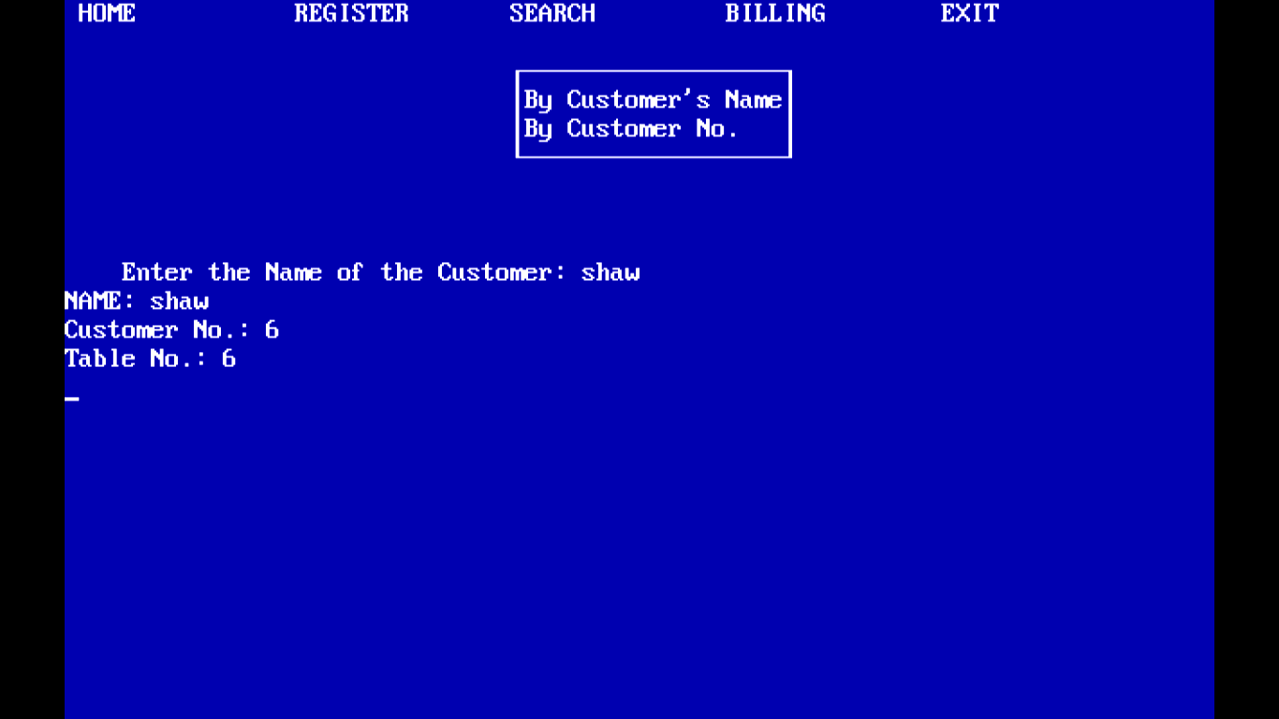

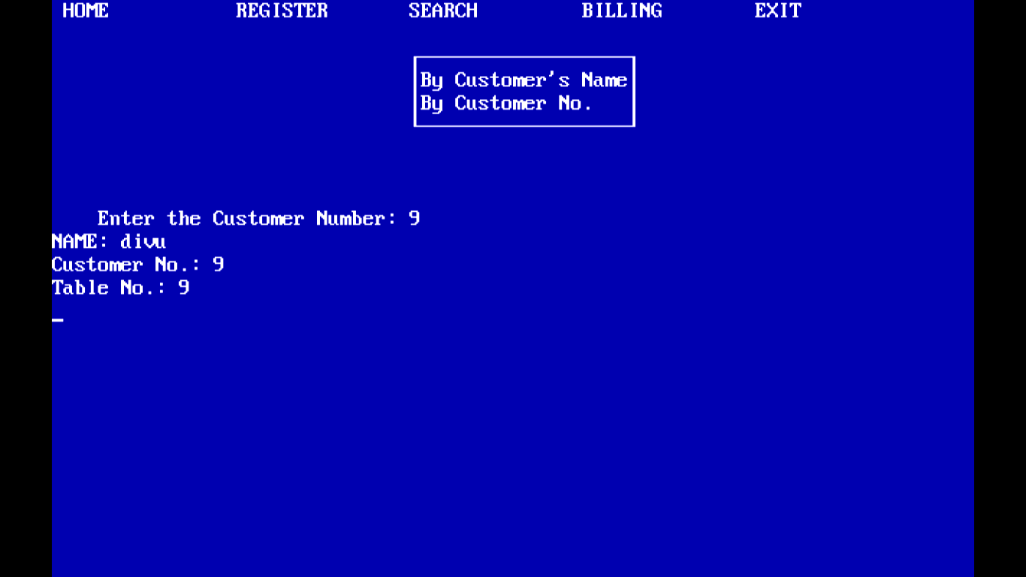

Page: #16/19

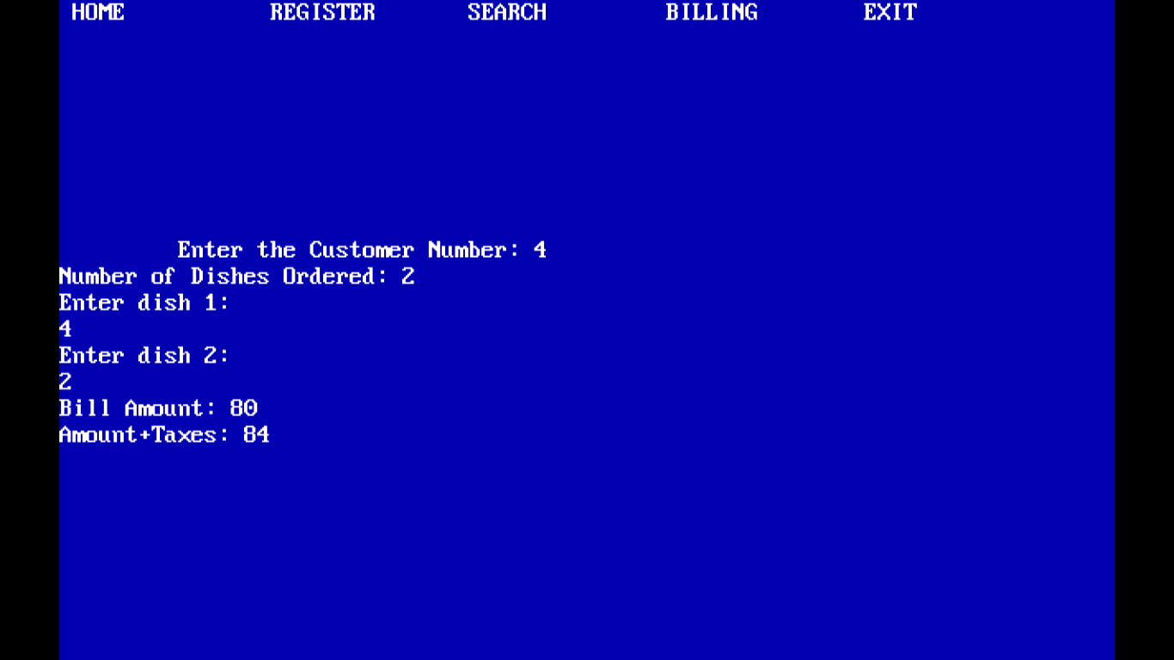

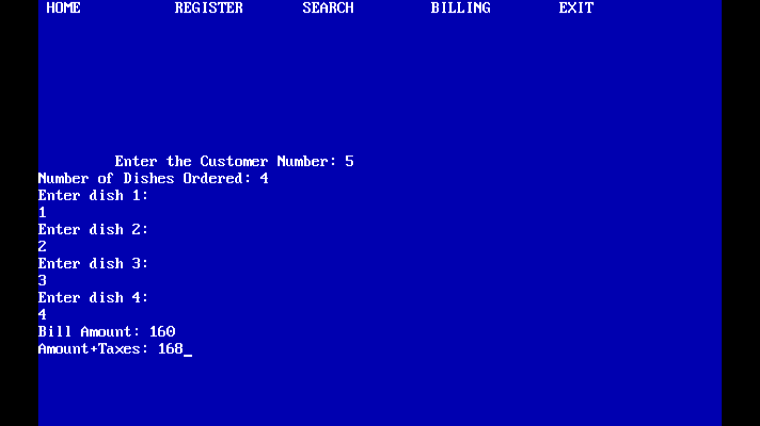

Page: #17/19

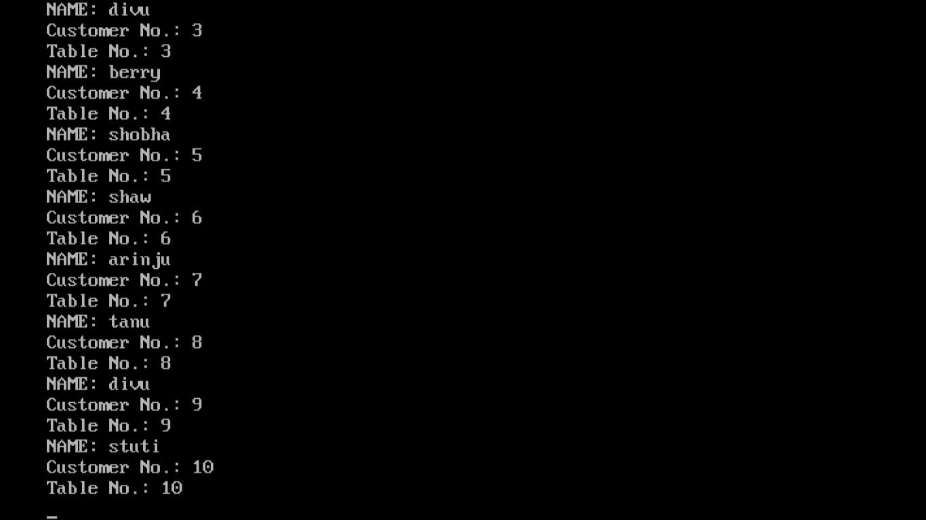

Page: #18/19

Hardware and Software Requirements

Hardware Requirement

Intel core/i3/i5/i7 or any equivalent

With at least 256 MB RAM

2 MB free space on hard disk

Color Monitor/LCD

Operating system & Compiler

MS Windows

Turbo C++ 3.1 Compiler

Page: #19/19